Agenda:

* ~~What and how should we demo? (walk through a gameplan)~~
* **~~Consolidate all current documentation~~**

##### ~~Help with select datatype pickers~~

* **~~Integrate select_data_type_drop-down’s dataset getters and assignment to x-axis/y-axis values~~** ~~- test if it works~~

Notes:

* Andre: Let’s aim for Monday by 10pm for the final code submission; breathing room to debug or deal with the unexpected +2
* We all enjoyed working together, but are glad the project is nearly over.
* Balance of time on setup and troubleshooting vs. development
* Highlight of the semester even with the headaches
* C: START, STOP… enjoying the summer, coding
* E: START submitting pull requests, KEEP in touch
* We really didn’t have much to reflect on except wishing there were fewer issues and bugs to deal with, but all had a good experience as working as a team
* Voiceover for video
* Merge code and followup on Discord
* “Been great working with ya’ll”
* Photo - meet early or photoshop our heads together?
* native-gesture-handler issues
* Wow, championship belt FR

Action Items:

* Meet before 1pm for team photo (need to submit PPT + Video *before* 1pm Tuesday) <https://memphis.instructure.com/courses/64955/assignments/613576?module_item_id=2319272>
* Final Checklist:
  + PPT (reflection slides)
  + Video voiceover
  + Timesheet (completed, exported, and formatted for excel)
  + Documentation -> consolidate in documentation_spring_2023 branch under docs/
    - **“Maintenance and Help Guide”:**
      * **Recommended changes** - update to current react (componentDidMount(), other functions deprecated), update out of date packages (too many to list), recommend setting up a repo-wide setup - package.json in root to run backend_worker/storage/frontend package.jsons (npm install once), add graph button , unique keys for virtualized lists, others?
      * **Bugs/Issues (Existing + Resolved)** - screen still shaking (temp: dev tools -> styles tab -> in #root body, disable ‘min-height: 100%’, go through elliott’s setup guide and mention anything listed there, FlatList unique keys, consolidate packages known to be installed, Firefox (build, os versions) not displaying navbar, instructor codes, report everything current in dev tools console (componentWillMount, componentDidMount, componentWillReceiveProps, *DOM p/w not contained in form*, .js->.jsx, reload on any window resize,
      * **Mac (M1/M2+Intel) Guide**
      * **Ubuntu/Linux Guide**
    - **“Source Code Document”: Feature Changes/Additions** - (Graph.js, GraphsContainer.js, DatasetScreen.js(?), AdminNavigation.js, Dataset.js, **did we touch anything else?**
    - **README.md (Ludolab/PeerPresents)** - theirs
    - **“**Software Architecture Document”: N/A - exists
  + Export, push Meeting Notes
  + Export, push Deliverable objects
  + Update our README.md (chrismsmalley/PeerPresents)

**Timesheet Public Link**:<https://docs.google.com/spreadsheets/d/1KkuSKicscj2jMrfE9vEN9oWsRSRhucUxY9IdotBWA_4/edit?usp=sharing>

GH Projects Kanban Board Pics:

Beginning of Sprint 4

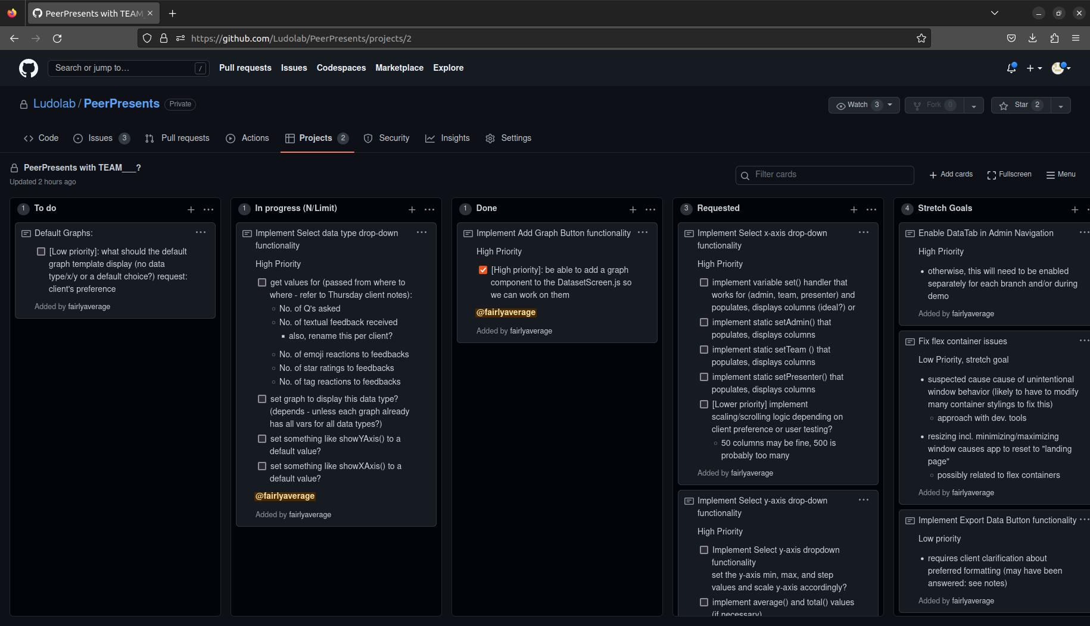

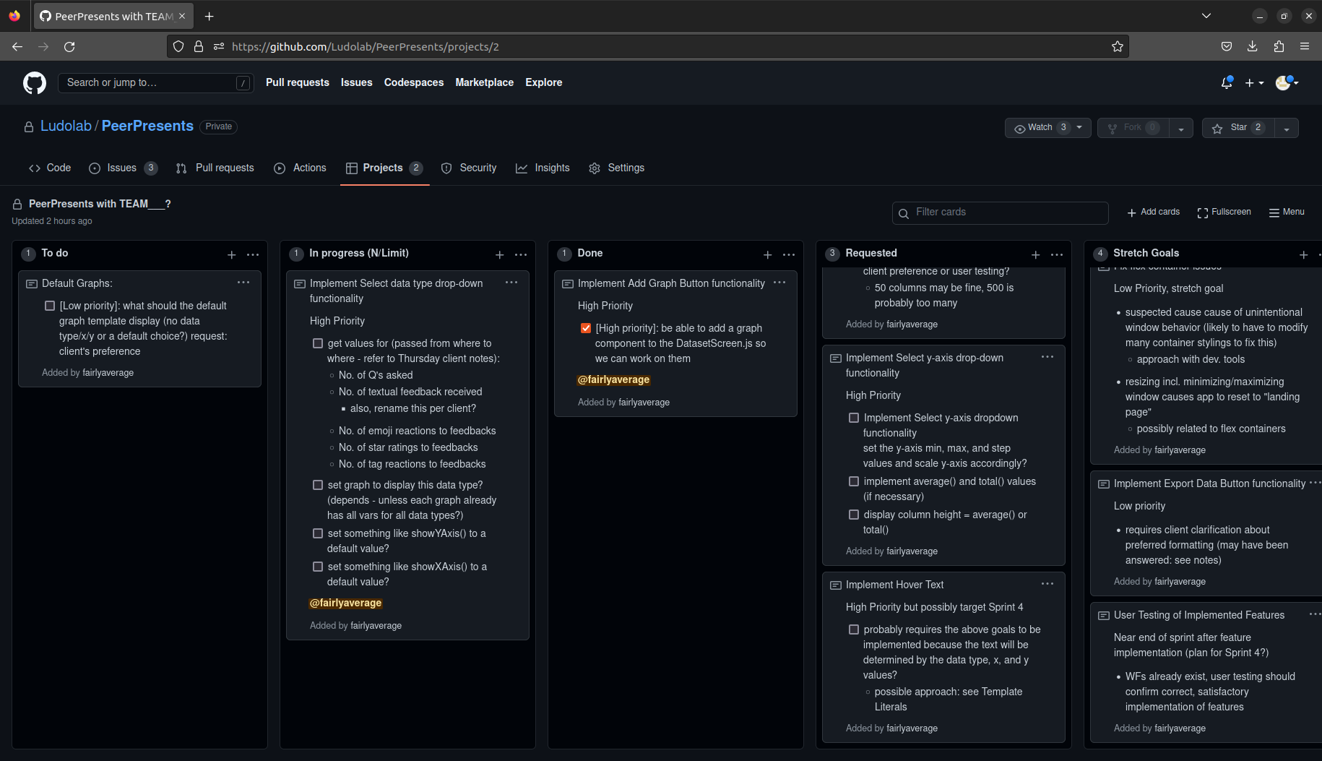

End of Sprint 4/5

